Writing 1 HOUR
TASK 01:
You should spend about 20 minutes on this task.
The diagram below shows one method of manufacturing ceramic pots. Summarize the information by selecting and reporting the main features, and make comparisons where relevant.

Write at least 150 words.
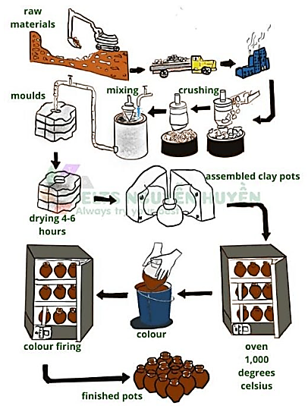
TASK 02:
You should spend about 40 minutes on this task.
Immigration has a major impact on the society.
What are the main reasons of immigration? To what consequences can it lead?
Write at least 250 words.
Writing 1 HOUR
TASK 01:
You should spend about 20 minutes on this task.

You recently bought an electronic device for your home. Your friend wants to buy the same device and has asked for your advice. Write a letter to your friend.
In your letter
- describe the device
- please explain why you bought it
- say whether or not your friend should buy it and why.
Write at least 150 words.
You do NOT need to write any addresses.
Begin your letter as follows:
Dear ……………,

TASK 02:
You should spend about 40 minutes on this task.
Immigration has a major impact on the society.
What are the main reasons of immigration? To what consequences can it lead?
Write at least 250 words.

